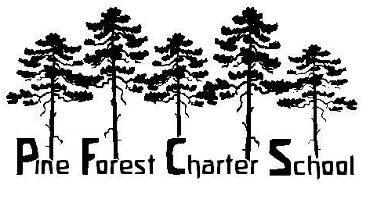
An Arizona Charter School Guided by the Core Principles of
Public Waldorf Education
Established in 1995
2257. E. Cedar Ave, Flagstaff, AZ 86004, 928-779-9880, Fax 928-779-9792
Notice of Non-Discrimination and Non-Retaliation
In compliance with Title VI and Title VII of the Civil Rights Act of 1964, Section 504 of the Rehabilitation Act of 1973, the Americans with Disabilities Act of 1990, the Age Discrimination Act of 1975 and other federal, state and local laws, and in accordance with our values, Pine Forest Charter School (PFCS) does not discriminate against students or employees on the basis of race, color, religion, creed, national or ethnic origin, sexual orientation, age or disability in the administration of any of its educational programs and activities or in its employment practices.
PFCS does not discriminate on the basis of alienage or citizenship status, gender (including gender identity), marital partnership status, military status, predisposing genetic characteristics or domestic violence victim status in its employment practices.
In accordance with Title IX of the Education Amendments of 1972, Pine Forest Charter School does not discriminate on the basis of sex in its educational programs, activities or employment practices.
Finally, PFCS does not retaliate against any students or employees for exercising their civil rights under the aforementioned Acts and Amendments.
PFCS has designated Kelly Smith the school’s Section 504 Coordinator. Kelly Smith will handle all inquiries regarding 504 efforts to comply with and carry out its responsibilities under this law. She may be contacted at Pine Forest Charter School, 2257 E. Cedar Ave., Flagstaff, AZ 86004. Her phone number is 928-779-9880 and email is ksmith@pineforestschool.org .
PFCS has designated executive director Cindy Roe as the school’s Title IX Coordinator. The PFCS Governing Board president and Cindy Roe will handle all inquiries regarding Title IX efforts to comply with and carry out its responsibilities under this law. Each may be contacted at Pine Forest Charter School, 2257 E. Cedar, Flagstaff, AZ 86004. The phone number is 928-779-9880. The email address for the executive director is croe@pineforestschool.org and for the board president is info@pineforestschool.org .
June 2019

